Homework #10 – Bellman Ford

Instructor: Ali Sharifian

Points: 16

Execute the Bellman Ford algorithm on the below network to provide the list of distances and previous nodes from the source. Assume node a is the source node. Fill out the below provided table.

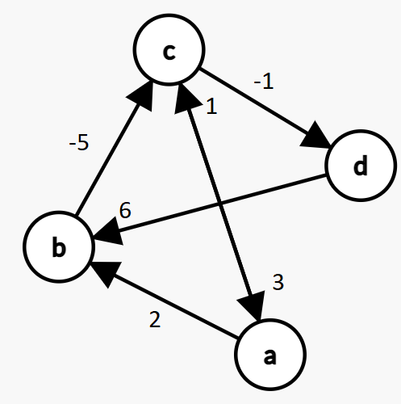

Note that there are 4 nodes and 6 edges in the above graph. The link between c and a is bi-directional, so that counts as two edges. Also, to clarify because the above image may not be fully clear:

c->a has an edge weight of 3

a->c has an edge weight of 1

d->b has an edge weight of 6

For an example, see the **Sample Bellman Ford Problem and Solution.pdf** document posted on Canvas. In addition, in the table, you must cross out the old value. Otherwise, you will get points deducted, up to and including receiving zero credit.

|  |  |  |
| --- | --- | --- |
| **Node** | **Distance from a** | **Previous Node** |
| a | ~~Infinity~~ |  |
| b | ~~Infinity~~ |  |
| c | ~~Infinity~~ |  |
| d | ~~Infinity~~ |  |

|  |  |  |  |  |
| --- | --- | --- | --- | --- |
| **Node** | **Distance from a crossed out** | **Distance from a** | **Previous Node crossed out** | **Previous Node** |
| a | ~~Infinity~~ | 0 |  | Nil |
| b | ~~Infinity~~ | 2 | ~~Nil~~ | a |
| c | ~~Infinity~~ | -3 | ~~Nil~~ | b |
| d | ~~Infinity~~ | -4 | ~~Nil~~ | c |

Literation 1:

a->b: infinity > 0+2=2 ? Yes, update

b->c: infinity > 2+(-5)=-3 ? Yes, update

c->d: infinity > (-3)+(-1)=-4 ? Yes, update

d->b: 2 > (-4) +6=2? No, don’t update

a->c: -3 > 0 + 1=1? No don’t update

c->a: 0 > (-3) + 3=0? No, don’t update

Literation 2:

a->b: 2 > 0+2=2? No, don’t update

b->c: -3 > 2+(-5)=-3? No, don’t update

c->d: -4> (-3)+(-1)=-4? No, don’t update

d->b: 2>(-4)+6=2? No, don’t update

a->c: -3 > 0 + 1=1? No don’t update

c->a: 0 > (-3) + 3=0? No, don’t update

Literation 3:

a->b: 2 > 0+2=2? No, don’t update

b->c: -3 > 2+(-5)=-3? No, don’t update

c->d: -4> (-3)+(-1)=-4? No, don’t update

d->b: 2>(-4)+6=2? No, don’t update

a->c: -3 > 0 + 1=1? No don’t update

c->a: 0 > (-3) + 3=0? No, don’t update